|  |  |  |  |  |
| --- | --- | --- | --- | --- |
| Sudharshan Isaac Tay |  |  |  | makerforce.io/sentiforce |

SentiForce

Progress report 1 [July-August]

Goal setting and planning completed

Table of Contents

1. Progress Summary 2

Timeline

Objectives Completed

Objectives in progress

1. Project Details 3

Project Specifications

Thrust to Weight Calculations

Power Consumption

Case Design

PCB Design

Camera and Vision

Cost

Manufacturing Methods

1. Appendix 10

Bill of Materials

References

# Progress Summary

|  |  |
| --- | --- |
|  | This is a quick summary of the progress made with the SentiForce project from the month of May-August. |

## Timeline

## Objectives Completed

##### Project Planning

##### Timeline Creation

##### Custom Edison PCB design

##### Cost calculations

##### Viability calculations

##### Materials purchasing

## Objectives in progress

##### SentiBot Shell Creation

##### Camera

# Project Details

|  |  |
| --- | --- |
|  | The SwarmForce project is a project which intends to use Unmanned Aerial Vehicles [UAV] to carry out swarm research. This project will involve researching both into swarm algorithms as well as finding a suitable aerial platform which is able to use these swarm formations for useful applications.  This involves designing and building a high strength and highly versatile flying machine which is able to adapt to the environment and use its versatility along with other SentiBots to perform various tasks unlike current robots which are currently designed and are only able to do one specific task. |

## Project Specifications

|  |  |
| --- | --- |
|  | In this section, I will be going into some of the specs of the SentiBot drone. The SentiBot is using a recently invented method of flying call the “Spherical Flight Vehicle” using a single thrust source and 4 control surfaces to essentially form a monocopter drone. In their research they made a large and bulky drone using a massive motor and prop combination. We intend on miniaturizing this design to form a compact and agile monocopter design.  I will be using a 50mm EDF (Electric Ducted Fan) to provide the thrust for this design along with a bunch of sub-micro servos to control the flaps on the drone. Since the EDF can provide up to 500g of static thrust in a very small package of just 50mm, our drone can have a 3:1 thrust to weight ratio allow it to be very fast and agile. It also allows for it to carry up to 2 times its own weight in payload. Refer to the List of Materials in the Appendix for more information.  Our drone’s estimated weight is about 160g-200g with the majority of the weight being the battery and the EDF unit itself. Since we are using very light weight components the flight time of the drone can be extended to a respectable 15-20min on a fully charged 1000mAh battery without carrying any load. This will allow the SentiBot to complete most missions whether it is in Search and Rescue or Military Reconnaissance.    C:\Users\Sudhar\Computer Documents\Desktop\IRP\Frame Design\Version 1\Capture.PNG |

## Thrust to Weight Calculations

|  |  |
| --- | --- |
|  | In this section I will be making some basic calculations about the thrust to weight ratio  and the maximum payload carrying capabilities. From my list of materials we can see that the total weight of the components is 110g. From the .stl files I can estimate that the case will be about 30g and the Edison and my custom PCB will be about 20g. Thus, the total weight is 160g.  The thrust of this 50m EDF is about 500g thus the thrust to weight ratio is just about 3:1. This gives the drone just the right combination of power and payload carrying capabilities. With a 3:1 ratio it can also carry a lot of payload and just a combination of 5 SentiBots can carry 1kg in payloads. Their modular and adaptive nature compliments the payload carrying capacity nicely.  Looking at the throttle curve of a typical EDF below, we can see that it see pretty linear to the RPM [Revolution per minute]. Thus, we can assume that the number of amps drawn by the motor is quite proportional to the thrust output as well. This is explained In greater detail below in the power draw and battery life section.  Taking a look at the output airspeed as well, we can tell that there is plenty of airspeed for the control surfaces to use in static hovering. This will also help the SentiBot is an extremely agile drone as the amount of control we have on the drone depends on the amount of air being moved past the control surfaces the control we have on the drone will increase a lot as well.  http://www.electrifly.com/miscproducts/gpmg3910-chart-b.jpg  **Figure 1** |
|  |  |

## Power Consumption

|  |  |
| --- | --- |
|  | In this section I will be talking about the power consumption and by extension the power consumption.  Our EDF consumes about 18A max when it is producing max thrust which is about 500g. We only require a 1:1 thrust to weight ratio to hover so for the purposes of calculating flight times, we can assume that the SentiBot is always hovering. Referring to above we see that the weight of a single SentiBot is around 160g, we will only need about 1/3 of the current to create that much thrust. That translates to about 6A of current draw from the EDF.  Next, looking at the servos, we can see that all my servos are relatively low power and along with the Edison will only draw less than 1.5A. This causes there to be total current draw of 7.5A max when the drone is hovering,  The batteries that we are using are 11.1V [3S] 1000-1350mAh Lithium Polymer batteries with up to a 25C current draw. This means that the battery can supply 1.3A for 1h continuously before it runs out. We will be drawing about 7.5A from it thus, $$\frac{1.3A}{7.5A}*60min=10min$$ In an optimal scenario we would get a slightly better result ranging from 10-15min. |
|  | http://www.hobbyking.com/hobbyking/store/catalog/21338(2).jpg**Figure 2** |

## Case Design

|  |  |  |
| --- | --- | --- |
|  |  | Our case design is based off the spherical flight vehicle and it has been adapted to be more optimized for the EDF which is going to be placed in the SentiBot. It also has a space to place electronics and Vision equipment which allows SentiBot to see and therefore navigate its surrounding.  https://unmanned.okstate.edu/sites/default/files/field/image/Screen%20Shot%202014-05-14%20at%209.48.04%20AM.png.  **Figure 3**  Furthermore, the SentiBot is also optimized to allow for easy swap ability of the electronics and sensors onboard as it has a removable electronics bay which is located on top of the robot unlike the complicated setup seen here where the electronics are in the drone itself.    **Figure 4-5**  I am still not completely done with the design and it still needs some improvement. Expect some changes in next month’s progress report. |

## PCB Design

|  |  |
| --- | --- |
|  | As mentioned above in the previous sections, I will be making a custom intel Edison board which will connect the intel Edison to a separate Atmel 328P which is controlling the quadcopter. This means that the Edison will not have to directly control the EDF and the servos directly but rather will just communicate to the Atmel through serial passing it commands on what to do to the quad and how to move it around. The PCB also breaks out the USB to allow for a small USB camera to be connected to the Edison for the vision to work.    **Figure 6**  This is the circuit diagram for the design. The circuit is pretty self-explanatory with the intel Edison connected through a 1.8V to 3.3V level shifter to the Atmel chip and the 9DOF IMU chip is connected to the Atmel chip through I2C as well. I also have a bunch of regulators and ICSP out for programming the Atmel chip.  C:\Users\Sudhar\Computer Documents\Desktop\IRP\Circuit Design\Images\Final PCB 1.PNG C:\Users\Sudhar\Computer Documents\Desktop\IRP\Circuit Design\Images\PCB render 1.PNGC:\Users\Sudhar\Computer Documents\Desktop\IRP\Circuit Design\Images\PCB render 2.PNG |

**Figure 7-9**

## Camera and Vision

|  |  |
| --- | --- |
|  | The camera and vision part of the system is something which has not been completely figured out yet. As of now, we are intending to have just have one camera on each Sentibot and use multiple Sentibots to accomplish stereo vision.  This is because a camera adds quite a bit of weight to the Sentibots which we have to try to avoid. I will be using as small and light a camera as possible with the Sentibots. Thus I am trying to get a quote from Ximea which manufactures very small USB cameras which  Is very useful in terms of weight conservation.  http://www.mathworks.com/cmsimages/87011_wm_ximea-MU9PC-gallery-image3.png  **Figure 9**  However, I am also considering a LiDar system which will enable each SentiBot to have depth analyzing skills and allow it to navigate its surroundings more effectively. However, the cost of a LiDar system might outweigh its benefits.  http://www.robotshop.com/media/files/images2/lidar-lite-laser-rangefinder-1-large_1.jpg  **Figure 10** |

## Cost

|  |  |
| --- | --- |
|  | The cost of the one SentiBot is about 150 dollars referring to the Bill of Materials. If we are going to make any number from 5-10 it will already cost us at least 1000 dollars. So we might need to find ways to lower costs. This can be achieved either through the usage of cheaper camera’s and equipment or my ordering in large amounts at the same time which will help to bring the costs down.  The camera we are using is currently quite expensive and other that that the most expensive items are our EDF and servos. By getting them cheaper or from other sources the cost can be brought down to about 100 dollars which is more viable for the project. |
|  |  |

## Manufacturing Methods

|  |  |
| --- | --- |
|  | For manufacturing of the casing I will probably be using either classic FDM [Fused Deposition Modelling] printing or even SLS printing [Selective Laser Sintering] if the budget has space for it. However, it will be more economical to order everything from an outside vendor as the will get superior quality prints and will do a better job at finishing the print. However, it is not essential as we can feasible mass produce the models by ourselves but it will be a lot harder  PCB Manufacturing is a completely different ball game though. I as of the moment have no idea how to get it manufactured locally and cheaply in small numbers. I have found a few places overseas however like oshpark.com. I might even have to experiment with producing it myself but that would be considerably difficult. |
|  |  |

# Appendix

## Bill of Materials

|  |  |
| --- | --- |
| Intel Edison | 50 SGD |
| Custom PCB | 3 SGD each |
| 9DOF chip | 10 SGD each |
| Atmel 328P | 4 SGD each |
| Miscellaneous Electronics | 20 SGD |
| 55mm 500g thrust EDF | 20 SGD  each |
| 3.6g sub micro Servos (x5) | 5 SGD  each |
| 850mAh Lipo battery | 8 SGD  each |
| 18A ESC | 12 SGD  each |
| Case production | 3-5 SGD  each |
| Camera/Lidar | 16SGD |
| Total Startup Expenses | 168 SGD  PER SENTIBOT |

## Circuit Diagram

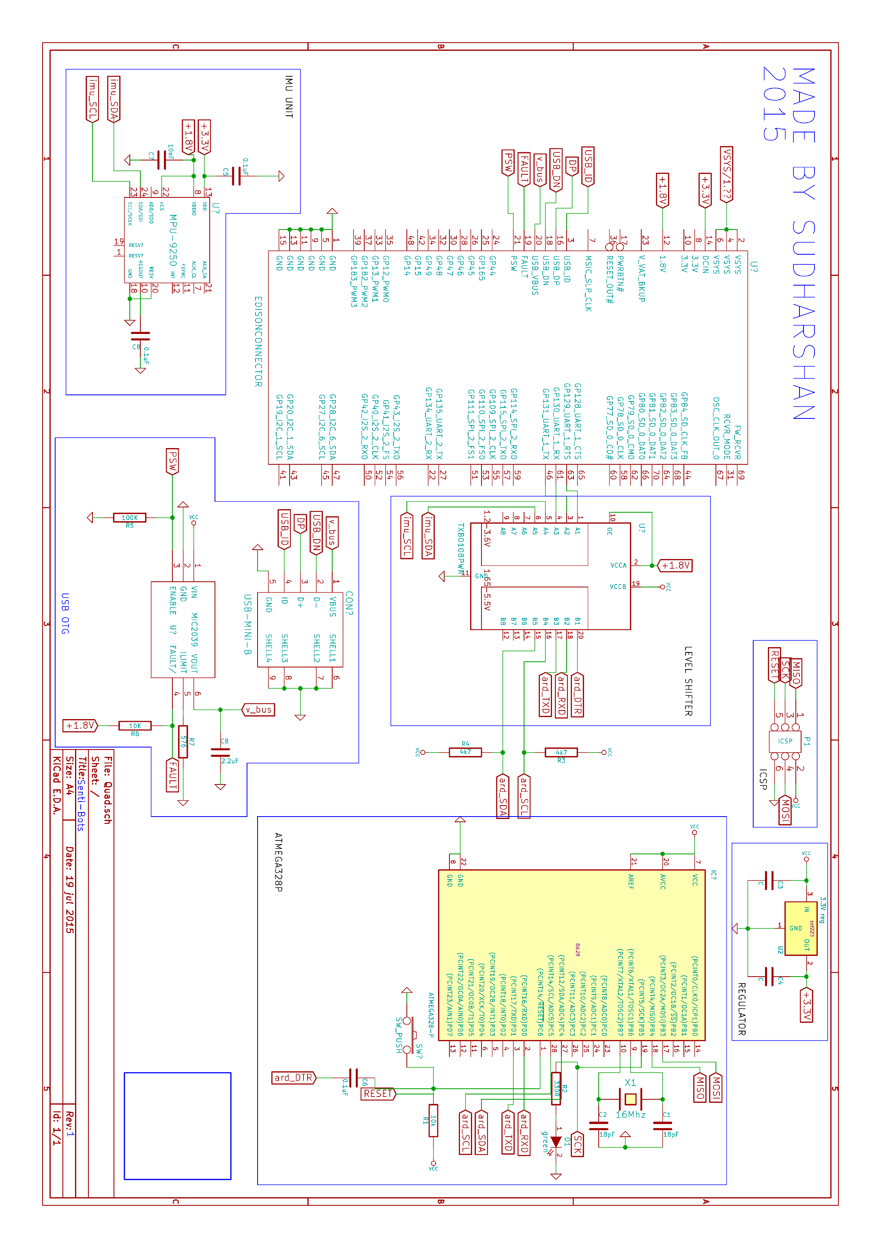

## References

|  |
| --- |
| FIGURE 1- http://www.electrifly.com/miscproducts/gpmg3910.html  FIGURE 2- <http://www.hobbyking.com/hobbyking/store/__21338__ZIPPY_Compact_1300mAh_3S_25C_Lipo_Pack.html>  FIGURE 3- <https://unmanned.okstate.edu/ufro> |
|  |